HW02 SOLUTION
Spring 2024
Vaught, Jacob

- A system’s TF is given as below (5pts)
$$G\left(s\right)=\frac{s+2}{(s+1)(s+5)}$$
(a) Identify the system’s zeros and poles and draw them with the zero-pole plot with proper conventions.

Poles: -1, -5
Zeros: -2
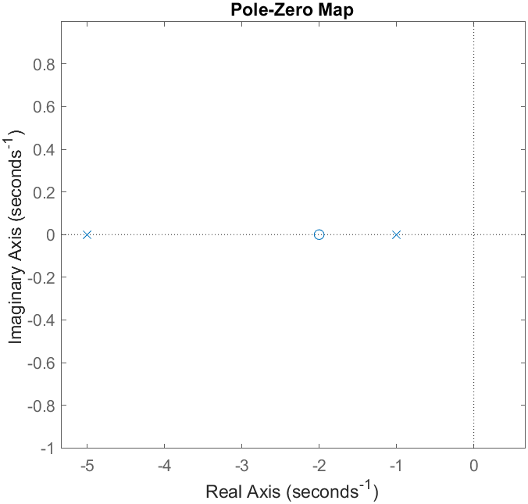
Figure 1: Zero-Pole Plot for Problem #1
(b) Derive the system’s time response to unit step input. Do not use MATLAB. You must show your step by step derivation.

To derive the time response g(t) to a unit step input u(t), we must first find the transfer function of the system subjected to a unit step. The Laplace transform of a unit step input is $U(s)=\frac{1}{s}$, so the output in the Laplace domain is $Y(s)=G(s)⋅U(s)$.

$$Y\left(s\right)=\frac{s+2}{(s+1)(s+5)}⋅\frac{1}{s}=\frac{s+2}{s(s+1)(s+5)}$$

We then perform a partial fraction decomposition of $Y(s)$ and then take the inverse Laplace transform. The partial fraction decomposition would look like:
$$Y\left(s\right)=\frac{A}{s}+\frac{B}{s+1}+\frac{C}{s+5}$$
Combining the decomposed form into a single fraction, we get:
$$Y\left(s\right)=\frac{A\left(s^{2}+6s+5\right)+B\left(s^{2}+5s\right)+C(s^{2}+s)}{s^{3}+6s^{2}+5s}$$
$$Y\left(s\right)=\frac{\left(A+B+C\right)s^{2}+\left(6A+5B+C\right)s+5A}{s^{3}+6s^{2}+5s}$$
Comparing with the original polynomial in the numerator, we set up equations for each power of s:
$$s^{2} Eq.→A+B+C=0$$
$$s^{1} Eq.→6A+5B+C=1$$
$$s^{0} Eq.→5A=2$$
Solving the system of equations (magic…):
$$A=\frac{2}{5};B=-\frac{1}{4};C=-\frac{3}{20}$$
Substituting the final values of A, B, C into the partial fraction decomposition, we get:
$$\frac{s+2}{s^{3}+6s^{2}+5s}=\frac{2}{5s}-\frac{1}{4\left(s+1\right)}-\frac{3}{20\left(s+5\right)}$$
Then completing a Laplace transform, where $\frac{1}{s}=1; \frac{1}{s+a}=e^{-at}$
$$y\left(t\right)=\frac{2}{5}⋅1-\frac{1}{4}⋅e^{-t}-\frac{3}{20}⋅e^{-5t}$$

- Determine ’system type’ and ‘system order’ for each system given in the table below. (10pts)

System’s TF | System type | System order
$$G(s)=\frac{s^{2}+4s+7}{s^{7}+3s^{4}+12s^{2}}$$ | 2 | 7
$$G(s)=\frac{s^{2}+4s+7}{4s^{4}+5s^{2}+7}$$ | 0 | 4
$$G(s)=\frac{s^{2}+4s+7}{s^{6}+5s^{4}+4s}$$ | 1 | 6
$$G(s)=\frac{s^{2}+4s+7}{4s(5s^{4}+2s^{2}+7)}$$ | 1 | 5
$$G(s)=\frac{4s+7}{s^{9}}$$ | 9 | 9

To analyze the system type and order of a transfer function G(s), we consider the following:
- System Type: Determined by the number of poles at the origin, i.e., the number of times s as a standalone term appears in the denominator. A system with n poles at the origin is a Type n system.
- System Order: Determined by the highest power of s in the denominator. This represents the system's complexity.

- Find the system’s transfer function $\frac{C(s)}{R(s)}$. (10pts)
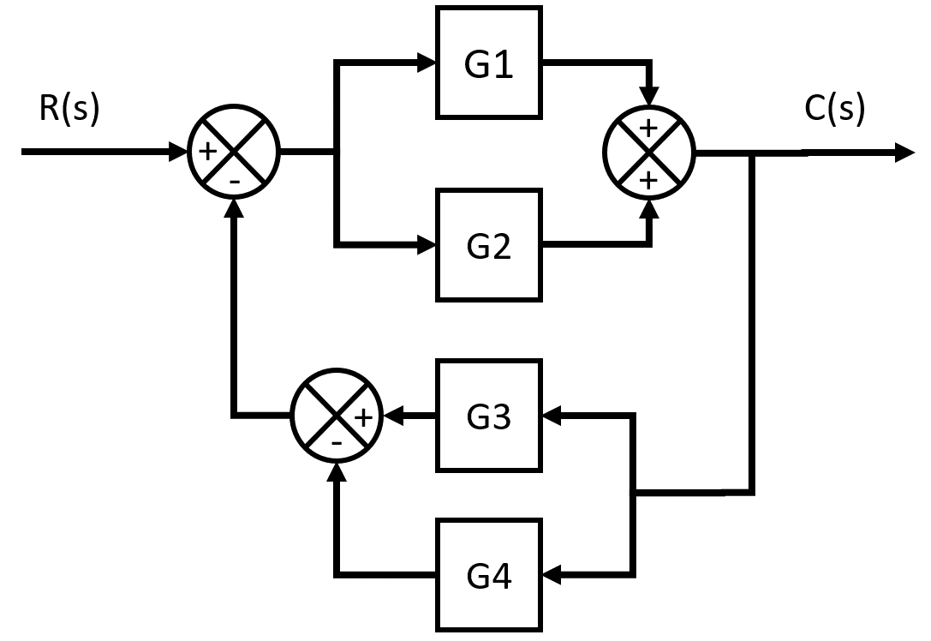
Figure 2: Original Block Diagram

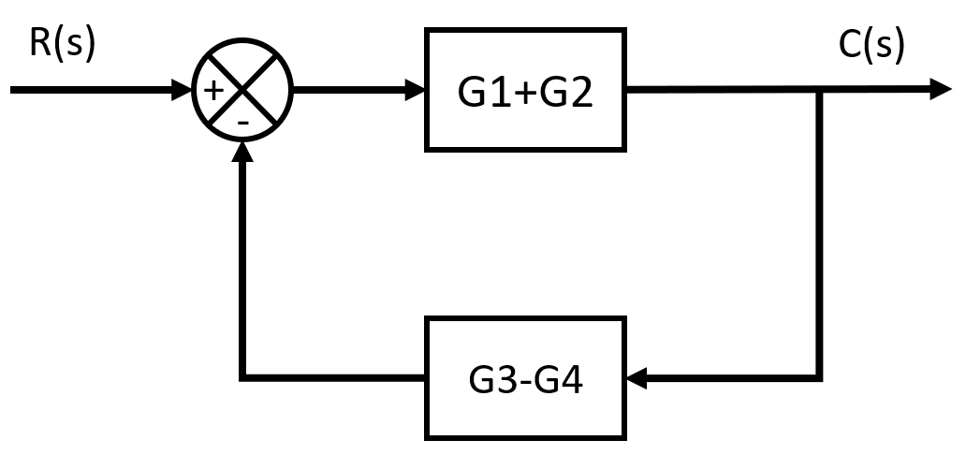
Figure 3: Simplified Block Diagram into Traditional Closed Feedback Form

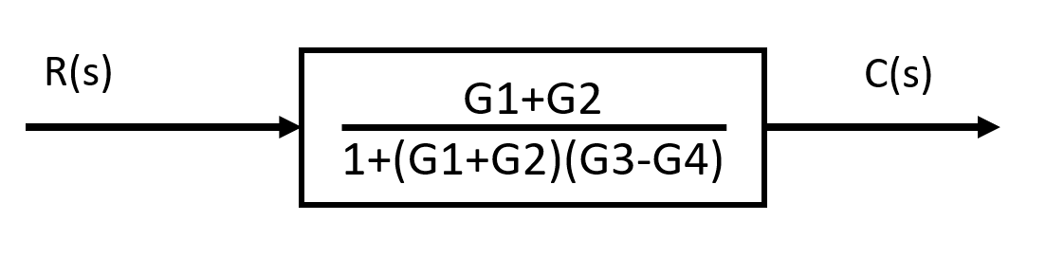
Figure 4: Final Transfer Function
Using the Closed-Loop Feedback Form, $T(s) = \frac{G(s)}{1+G(s)*H(s)}$, The final Transfer function was derived.

MATLAB Problems
- For a time domain function given below: (5pts)
$$x\left(t\right)=tsin\left(3t\right)$$
      - use built-in function laplace() to find its LT. Post screen capture of your codes and result below
      - next use expand () to process your transform result. Post screen capture of your codes and result below
      - then process the result from (2) with simplify(). Post screen capture of your codes and result below
      - with your final result from (3), use ilaplace() to convert back to time domain. Post screen capture of your codes and result below. Is the result the same as the original given function above?
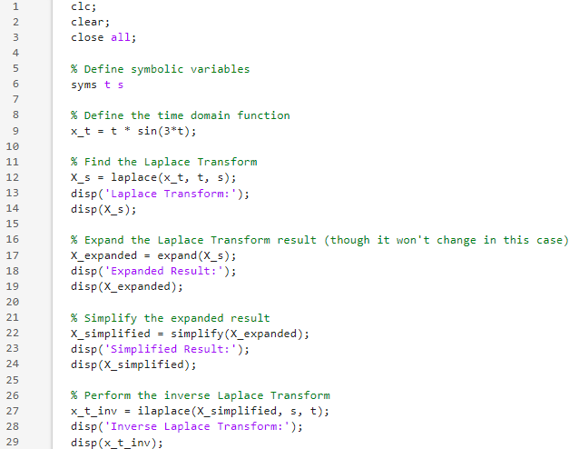
Figure 5: MATLAB Code for Problem #4
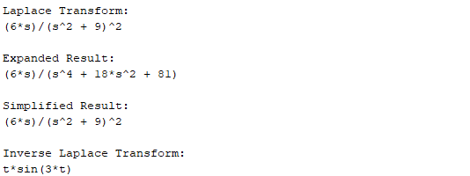
Figure 6: Results for Problem #4
I recorded the same result as the original function.

- For the function in s-domain given below: (5pts)
$$F\left(s\right)=\frac{5s+2}{s^{2}+3s+5}$$
      - Use function residue() to find its poles and residuals. Post screen capture of your codes and result below.
      - Find the time-domain function f(t) for F(s)
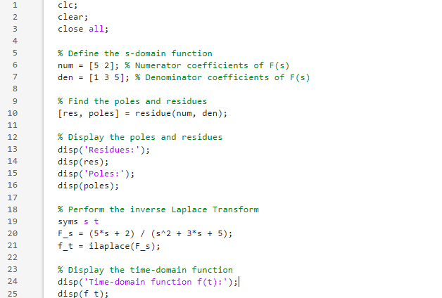
Figure 7: MATLAB code for Problem #5
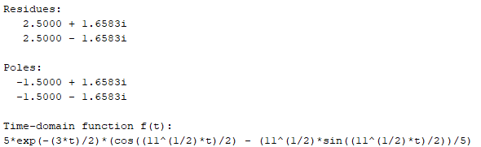
Figure 8: Solution for Problem #5

- Given a system’s TF as below (5pts)
$$G\left(s\right)=\frac{5(s+3)}{(s+2)(s+6)}$$
Generate this transfer function using function tf(), and then find the system’s response to unit step. Post screen capture of your codes and result below.
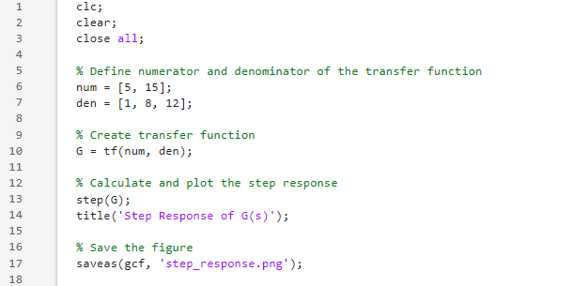
Figure 9: MATLAB Code for Problem #6
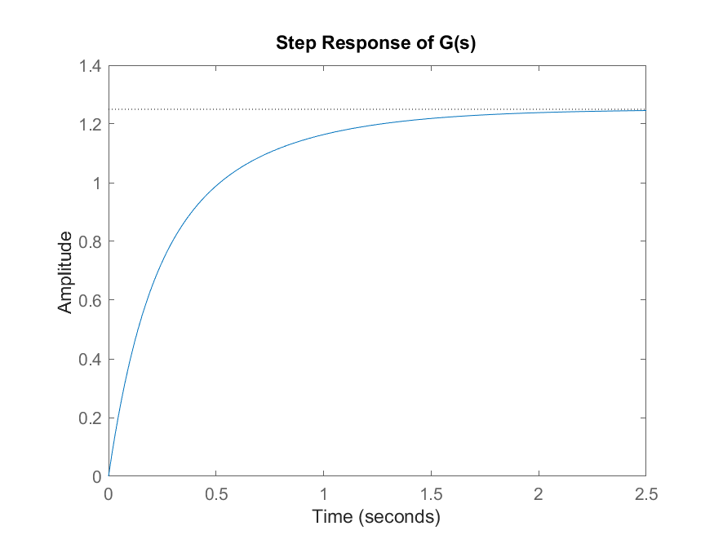
Figure 10: Plot of Problem #6

- Learn the zpk() function and use it to create transfer function alternatively in MATLAB for G(s) given above in problem 4. (5pts)
(1) Using MATLAB help, find out how the function zpk() generate a transfer function. Please provide a screenshot of your MATLAB help search result. What are the needed input information and what is the output of this function?
(2) Now using the system’s transfer function created by zpk(), find its response to unit step.
Post screen capture of your codes and result below.

The needed input information includes the zeros, poles, and gain of the transfer function.
The output of this function is a transfer function model in the ZPK format.
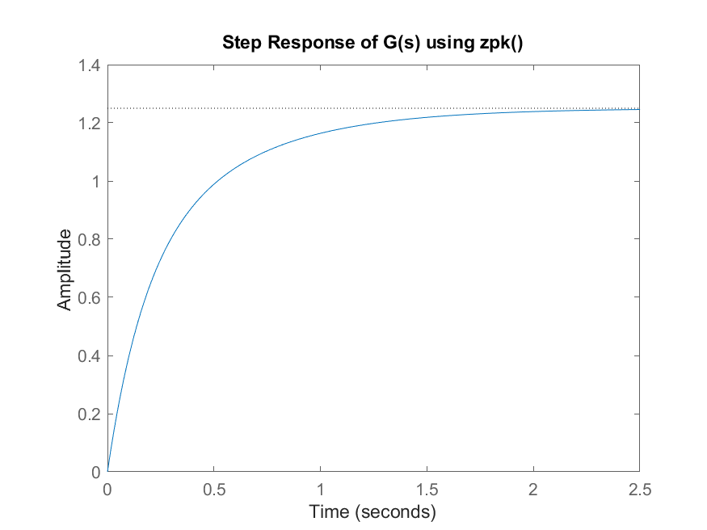
Figure 11: Plot of function.
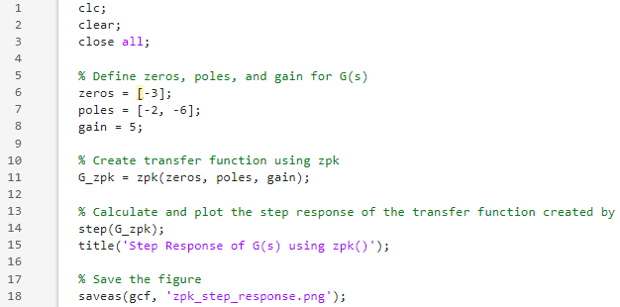
Figure 12: MATLAB code for Problem #7

2nd order ODE mechanical system (20 pts)

- Consider the mass-spring-damper system shown in the figure below.

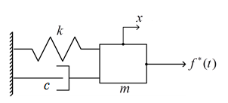
Figure 13: Spring-Damper system

- Draw FBD and deduce EOM. Clearly show your sketches and analysis step by step.

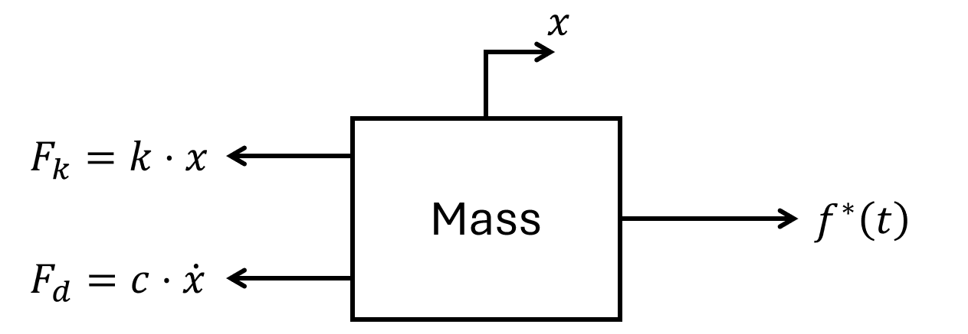
Figure 14: Free Body Diagram
$$m\ddot{x}+c\dot{x}+kx=f\left(t\right)$$
$$m\ddot{x}\left(t\right)+c\dot{x}\left(t\right)+kx\left(t\right)=f\left(t\right)$$

- Find the system’s transfer function $X(s)/F(s)$. Assume zero initial conditions.

Converting to Laplace domain:
$$ms^{2}X\left(s\right)+csX\left(s\right)+kX\left(s\right)=F\left(s\right)$$
Thus, we get as the transfer function:
$$H\left(s\right)=\frac{X\left(s\right)}{F\left(s\right)}=\frac{1}{ms^{2}+cs+k}$$

(3) Given a mass-spring-damper system with mass m=8 kg, damping coefficient c=10 N/(m/s), and spring constant k=600 N/m, determine the type of motion of the complementary response $x_{c}(t)$ and whether the system is stable or unstable.

The characteristic equation for the system's homogeneous differential equation $mx^{''}\left(t\right)+cx^{'}\left(t\right)+kx\left(t\right)=0$ is derived from assuming a solution of the form $x(t)=e^{rt}$, leading to:
$$8r^{2}+10r+600=0$$

We apply the quadratic formula to find the roots of the characteristic equation:
$$r=\frac{-b±\sqrt{b^{2}-4ac}}{2a}​​$$
Since the coefficients are real, the nature of the roots depends on the discriminant $D=b^{2}-4ac$.
For our given values:
$$D={10}^{2}-4\left(8\right)\left(600\right)=-19100<0$$
The discriminant is negative, indicating that the roots are complex conjugates. The negative real part of the roots implies that the oscillations will decay over time, demonstrating that the system is stable.

The damping ratio ζ is:
$$ζ=\frac{c}{2\sqrt{mk}}=\frac{10}{2\sqrt{8*600}}≈0.0722<1$$
Since the discriminant is negative and the damping ratio is less than 1, the system has a pair of complex conjugate roots with negative real parts. This indicates that the system's response will be underdamped oscillations.

The complementary response xc​(t) of the mass-spring-damper system will exhibit stable underdamped oscillations, characterized by oscillatory motion whose amplitude decreases over time.

- Use MATLAB to find out the system’s response to a sinusoidal input $f\left(t\right)=\sin{(5t)}$ for 20 second.
Please provide a screenshot of your MATLAB help search result for lsim() function.
Please provide a screenshot of your MATLAB codes that generate your result.
Please provide a screenshot of your MATLAB result (a plot).
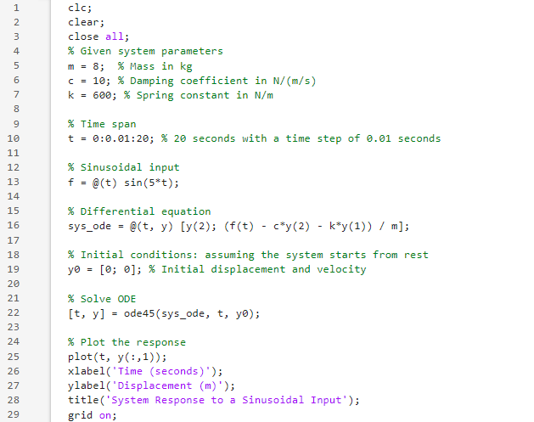
Figure 15: MATLAB code for Problem #8
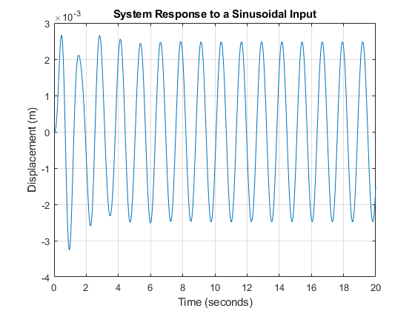
Figure 16: Plot for Problem #8

1st order system performance indicators

- A 1st order system is given with k=250 N/m, c=400 N/(m/sec). (25 pts)

- Giving the system’s transfer function G(s). Please indicate the value of time constant $τ$.

A first-order system like this is typically represented as a mass-damper system. The transfer function G(s) of a first-order system is generally of the form $\frac{1}{τs+1}$​, where τ is the time constant.
The time constant τ for a mass-damper system is given by $τ=\frac{c}{k}$​. Let's calculate it:
$$τ=\frac{c}{k}=\frac{400}{250}=1.6s$$
Thus, the Transfer Function is: $G\left(s\right)=\frac{1}{1.6s+1}$

- Write down the definitions for generic Performance Indicators(PI): x_{ss} and e_{ss}.

$x_{ss}$ is the steady state VALUE the system settles as t→∞: $x_{ss}=f\left(∞\right)=lim_{s→0}s*F(s)$
$e_{ss}$ is the steady state ERROR the system settles as t→∞: $e_{ss}=\frac{1}{1+k_{p}}, where k_{p}=\frac{1}{τ}$

- Calculate its generic PI: x_{ss} and e_{ss}, for step, impulse, ramp excitation, respectively.
STEP Response
$Y\left(s\right)=G\left(s\right)*\frac{1}{s}=\frac{1}{s\left(1.6s+1\right)},$ and $y\left(t\right)=e^{-0.625t}$
So, error $e\left(t\right)=1-e^{-0.625t}$
And $x_{ss}=lim_{s→0}s*\frac{1}{s\left(1.6s+1\right)}=1$
And $e_{ss}=1-x_{ss}=0$
IMPULSE Response
$Y\left(s\right)=G\left(s\right)*1=\frac{1}{1.6s+1},$ and $y\left(t\right)={0.625e}^{-0.625t}$
So, error $e\left(t\right)=-0.625e^{-0.625t}$
And $x_{ss}=lim_{s→0}s*\frac{1}{\left(1.6s+1\right)}=0$
And $e_{ss}=0$
RAMP Response
$Y\left(s\right)=G\left(s\right)*\frac{1}{s^{2}}=\frac{1}{s^{2}\left(1.6s+1\right)},$ and $y\left(t\right)=t+\frac{8}{5}\left(e^{-\frac{5}{8}t}-1\right)$
So, error $e\left(t\right)=t-t+\frac{8}{5}\left(e^{-\frac{5}{8}t}-1\right)=\frac{8}{5}\left(e^{-\frac{5}{8}t}-1\right)$
And $x_{ss}=lim_{s→0}s*\frac{1}{s^{2}\left(1.6s+1\right)}=∞$
And $e_{ss}=lim_{t→0}\frac{8}{5}\left(e^{-\frac{5}{8}t}-1\right)=1.6$

- Calculate its special PI, t_{r} for 95% rise, t_{d}, t_{s} for 5% error, for step excitation.

Given $y\left(t\right)=1-e^{-\frac{t}{τ}}=1-e^{-\frac{t}{1.6}}$

- $t_{r}​$ (Time for 95% Rise):
$$0.95=1-e^{-\frac{t_{r}}{1.6}}→t_{r}=4.79 seconds$$

- $t_{d}$​ (Delay Time):
$$0.5=1-e^{-\frac{t_{d}}{1.6}}→t_{d}=1.11 seconds$$

- $t_{s}$​ (Settling Time for 5% Error):
$$0.05=e^{-\frac{t_{s}}{1.6}}→t_{s}=4.79 seconds$$

- Use MATLAB script coding or Simulink to create the system given in Problem 9. (10 pts)
- Paste a screen capture of your script .m code.
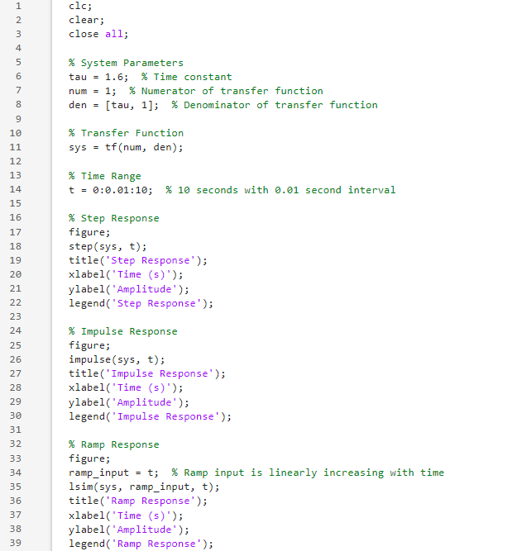
Figure 17: MATLAB Code for Problem #10

- Find its responses to step response, impulse response, ramp response for 10 seconds. Paste the plots of the responses. Please clearly mark which is to what input.

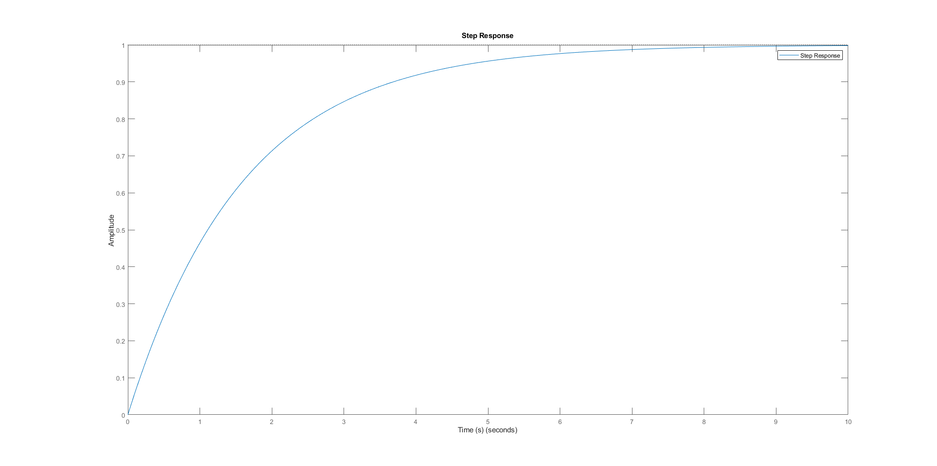
Figure 18: Step Response
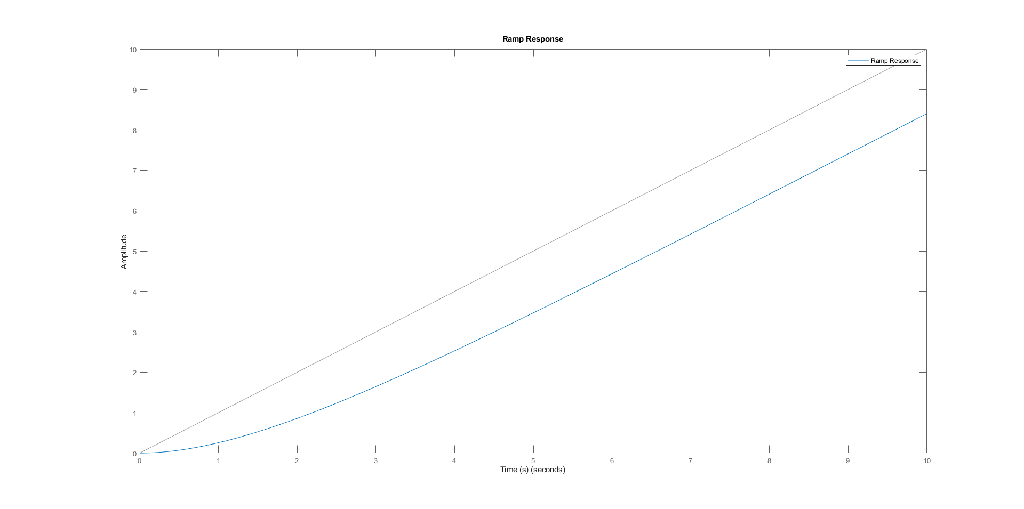
Figure 19: Impulse Response
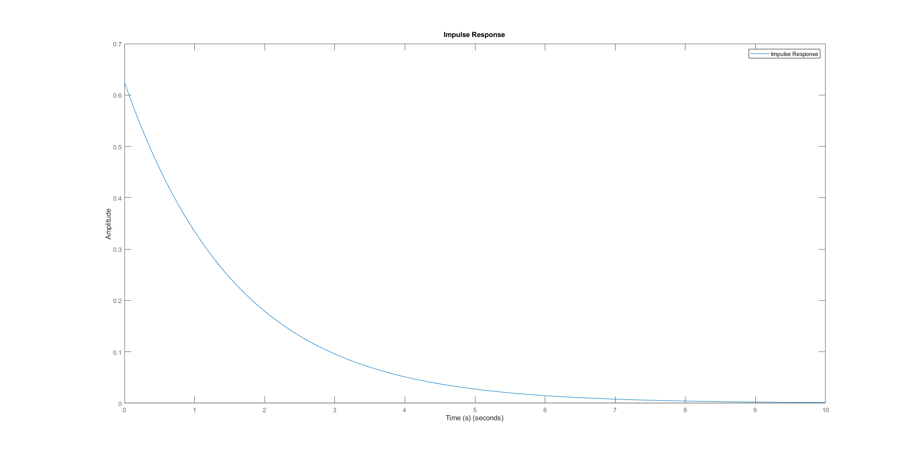
Figure 20: Ramp Response

